**“SMART ENERGY MANAGEMENT SYSTEM USING IoT”**

**THEME: SMART SYSTEMS**

**TEAM NAME: TESLA TRIBE**

**TEAM MEMBERS: 1) INNIYAVAN N K**

**2) KALAISELVAM G**

**3) KAVIN C**

**4) AKSHAYA N**

**5) AARTHIKA SELVI S K**

**6) CLARA J**

**Abstract:**

Smart cities are an innovative concept for managing metropolitan areas to increase their residents’ sustainability and quality of life. This article examines the management and evolution of energy generation, various storage systems and the applications they serve, and infrastructure technology’s current condition and future prospects. Additionally, the study also examines energy-related construction and transportation systems and technologies. The Smart Cities Energy Prediction Task Force predicts electrical usage using STLF, SVM, and e-learning machines. To keep a system working well throughout the year, fossil fuels must be utilised as a backup energy source. Technologies can only benefit if integrated into the city’s infrastructure. By 2050, it is anticipated that the global population will surpass 10 billion, with most people settling in metropolitan regions. Between 2020 and 2027, the global market for smart energy is anticipated to expand by 27.1% annually, from USD 122.2 billion in 2020 to USD 652 billion in 2026. In 2020, Europe will account for 31.8 per cent of total smart energy product sales. China’s GDP is projected to grow by 33.0 per cent annually, reaching USD 176.1 billion by the conclusion of the analysis period. Consequently, smart cities are expanding and blooming worldwide, yet there are no permanent standards.

Keywords:

[Smart cities](https://www.mdpi.com/search?q=smart+cities); [energy management system](https://www.mdpi.com/search?q=energy+management+system); [digitisation](https://www.mdpi.com/search?q=digitisation); [urban infrastructure](https://www.mdpi.com/search?q=urban+infrastructure); [Internet of Things](https://www.mdpi.com/search?q=Internet+of+Things).

INTRODUCTION:

The traditional electric grid (TEG) is a network of power generating stations, transmission lines, and distribution systems that are used to generate, transmit, and distribute electricity. However, with the increasing demand for energy and the need for a more efficient and reliable power supply, there has been a shift towards the development of smart grids (SG). According to a report published by International Energy Agency (IEA), a 30% increase in worldwide energy demand will be observed during 2017 and 2040. Another report of IEA revealed that the monthly electricity demand in Pakistan in FY 2019–2020 was around 120,000 GWh, and it is estimated to increase to around 200,000 GWh by FY 2024–2025. Further, there is a significant gap between the demand and supply of electricity in Pakistan, which results in frequent power outages or load shedding. The duration of load shedding varies depending on the region and time of year, but it can range from a few hours to more than 12 h per day. Developing nations such as Pakistan frequently struggle with issues including poor infrastructure, minimal access to power, and extreme poverty. Therefore, the effective use of power may improve access to electricity, lessen the strain on the nation’s limited resources, and accelerate economic growth. For instance, SG installation can help to lower energy losses, increase power supply dependability, and lower the price of electricity, This may be accomplished by taking a number of steps, such as installing smart meters (SMs), which can aid with monitoring and limiting power consumption, and using renewable energy sources (RES), which may reduce the nation’s reliance on fossil fuels. The adaptability and stability of the power supply can also be improved with the inclusion of an energy storage system (ESS).

A smart grid (SG) is an improved electric infrastructure that controls, regulates, and optimizes the usage of power using digital technology. In order to increase the effectiveness, dependability, and flexibility of the electricity supply, it involves the inculcation/integration of several technologies, including SMs, RES, and ESS. Demand-side management (DSM) and energy conservation (EC) strategies are also made possible by SG, which can help to lower the demand for power and encourage the effective use of energy. The Energy Management System (EMS) is a crucial component of DSM .The figure displays a representation of the SG, which is composed of multiple power sources, transmission lines, RES, EMSs, and a central control centre.

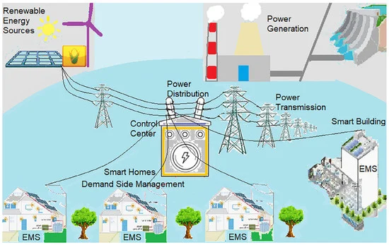

*The main contributions of this research work are as follows:*

1. Optimizes power Distribution: Using Automation Technologies like SCADA and distribution management systems (DMS) to monitor and control the distribution network in real time. This enables quicker fault detection, isolation, and restoration, reducing downtime and energy losses.
2. Integrates renewable energy sources: Developing renewable dominated power grid, leveraging power electronics and data analytics capabilities.
3. IoT Energy Monitoring system: it provides an easy way to automatically retrieve and analyse power quality events. It manages their electricity usage data including electricity consumption, current, voltage, power through an app.
4. Control for improved sustainability: One of the primary objectives of the study is to achieve significant energy savings in RT. By implementing the proposed EMS and leveraging its advanced features, the study demonstrates the potential for substantial energy reduction without compromising the comfort or functionality of the monitored systems. The sustainable are helpful for realizing the efficient utilization of energy supply and security, energy supply and security, energy sustainability has a closed loop positive feedback effect on the climate and environment sustainability.

HARDWARE COMPONENTS:

i)E-CON[Energy controller]: It inculcates current and temperature sensors.

ii) ESP32 Microcontroller

iii) Relay switches.

iv) An SCT013 30A 1V Non-Invasive AC Current Clamp Sensor.

v)MicroUSB Cable

vi)A general-purpose PCB

vii)A 10µf 16V capacitor

viii) Two 10K resistors (1/4 watt)

ix) One 33 Ohm resistor (1/4 watt)

SOFTWARE COMPONENTS:

i)Home Assistant :Home Assistant is [free and open-source software](https://en.wikipedia.org/wiki/Free_and_open-source_software) for [home automation](https://en.wikipedia.org/wiki/Home_automation) designed to be a central control system for [smart home](https://en.wikipedia.org/wiki/Smart_home) devices with a focus on local control and privacy. It can be accessed through a web-based [user interface](https://en.wikipedia.org/wiki/User_interface) by using [companion apps](https://en.wikipedia.org/wiki/Second_screen) for [Android](https://en.wikipedia.org/wiki/Android_(operating_system)) and [iOS](https://en.wikipedia.org/wiki/IOS), or by voice commands via a supported [virtual assistant](https://en.wikipedia.org/wiki/Virtual_assistant) such as [Google Assistant](https://en.wikipedia.org/wiki/Google_Assistant) or [Amazon Alexa](https://en.wikipedia.org/wiki/Amazon_Alexa).

ii)ShellyEM: Shelly EM is a Wi-Fi-operated energy meter with contactor control. Shelly EM is developed to monitor one, two, or three phases and allows you to monitor the status and history and the current and past electrical power consumption of each separate channel for the day, week, month, or year.

ENERGY DASHBOARD:

Today’s release of [Home Assistant Core 2021.8](https://www.home-assistant.io/blog/2021/08/04/release-20218/) contains a new energy dashboard ([demo](https://demo.home-assistant.io/#/energy)). The goal is to make it super easy for users to get insight into their energy usage. The dashboard has been designed to see at a quick glance how you’re doing today, with the option to also break down per hour to see what happened when. It also includes indicators to help you identify your reliance on the and if adding energy storage would help your situation.

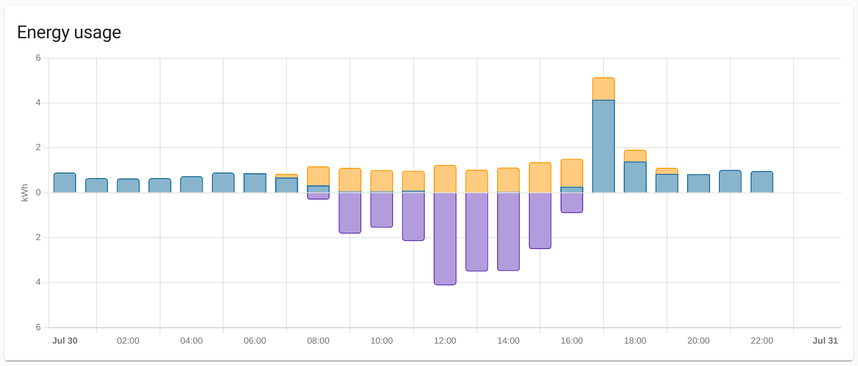

PROCESS FLOWCHART:

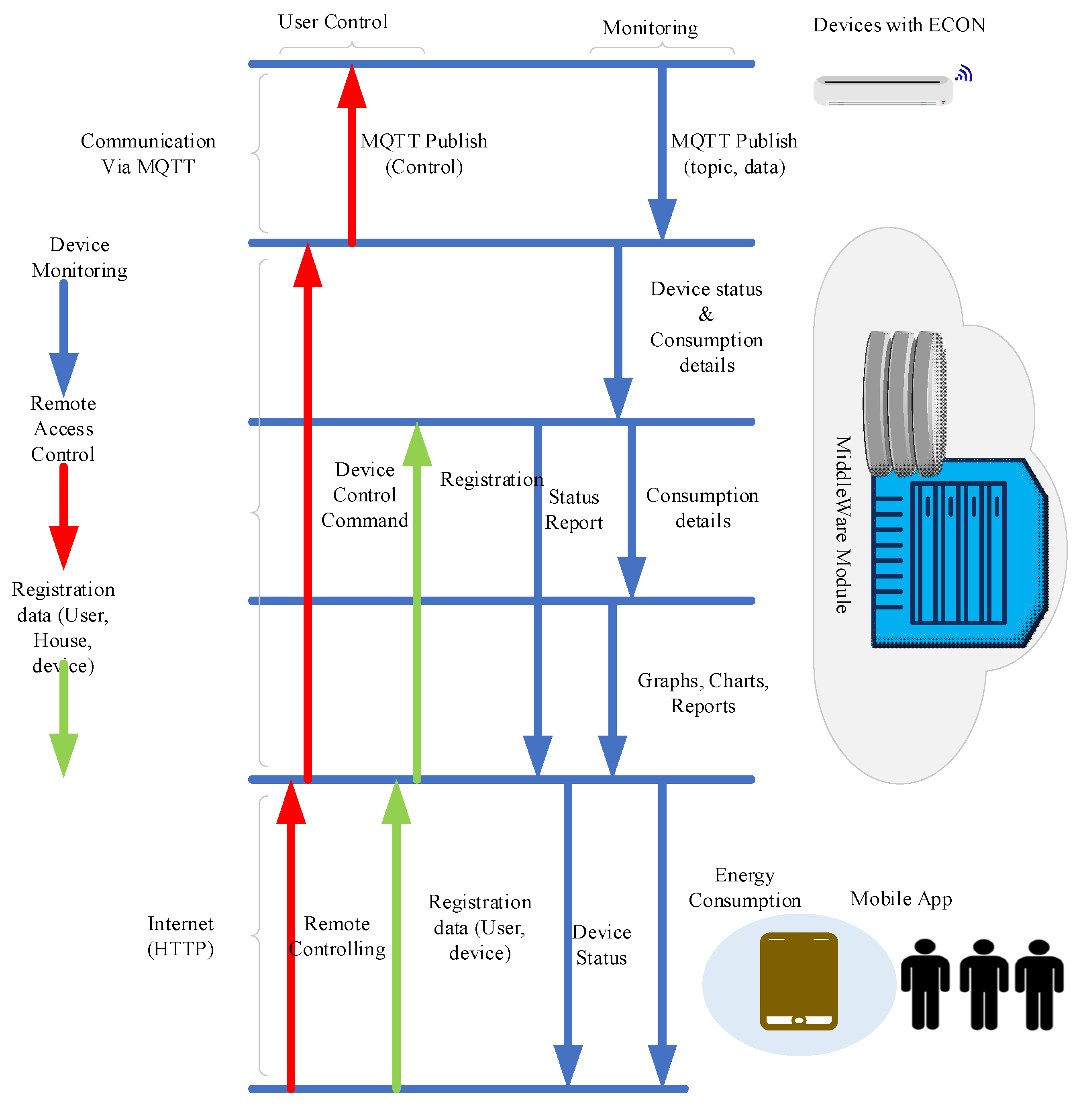

HOME ASSISTANT OVERVIEW:

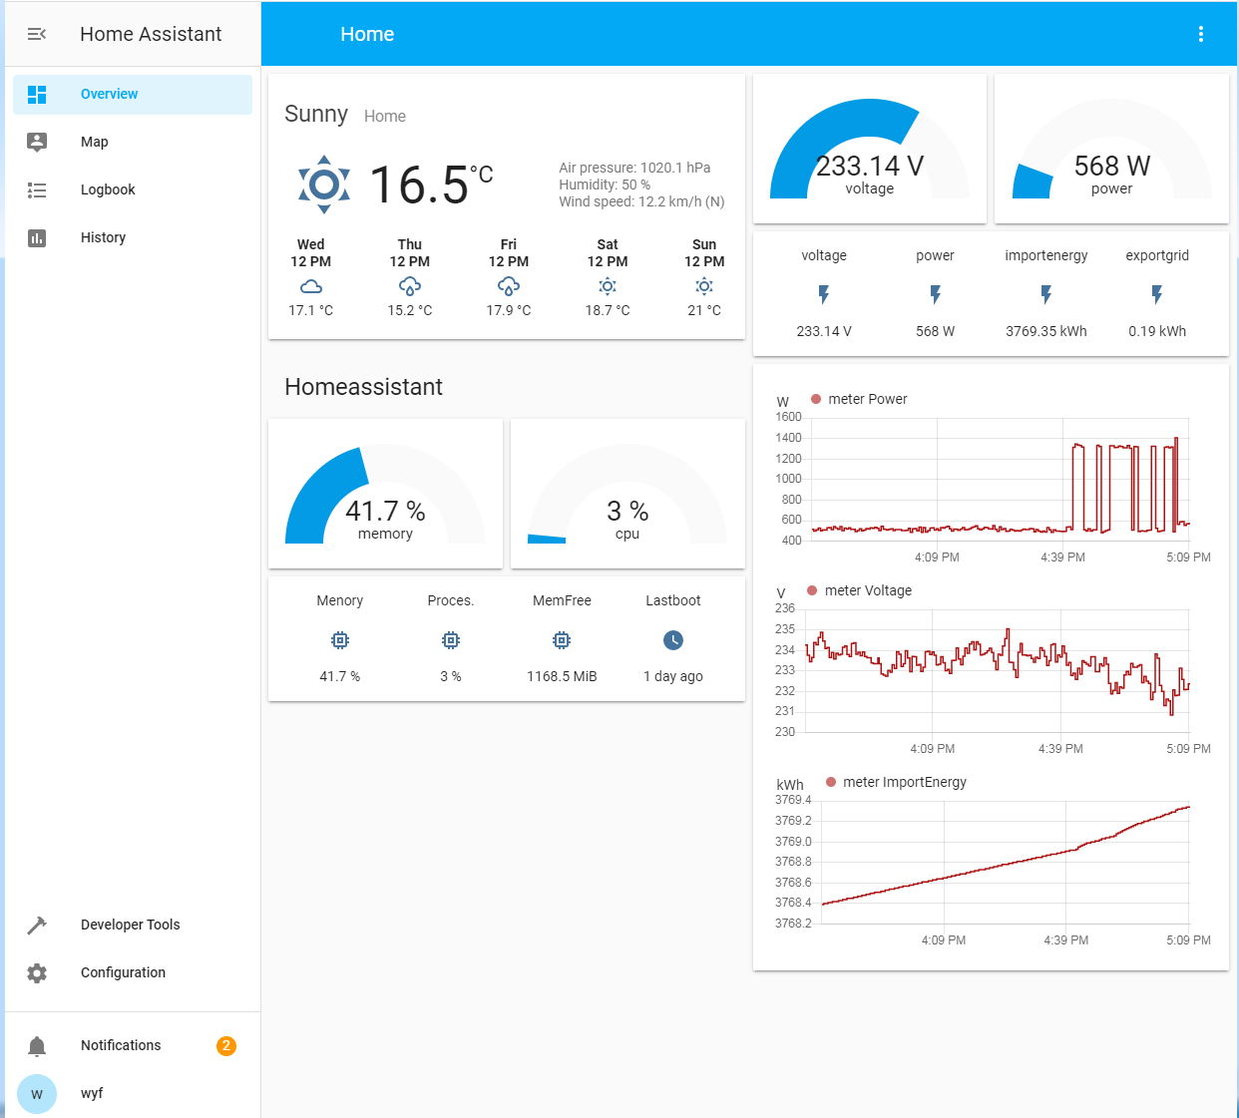

## Steps to Build Smart Energy Monitoring Device

Below are the steps you may follow to build an IoT-based smart energy monitoring device to track power consumption.

### Step 1: Install and Setup Home Assistant.However, the laptop will have a larger energy footprint and consume more power than the Raspberry Pi 3 or Raspberry Pi 4.

### Step 2: Install ESPHome Add-On in Home Assistant (HA).ESPHome is an add-on available in the Home Assistant that will be used to create custom firmware and flash it on the ESP32, NodeMCU, or D1Mini microcontroller. Follow these steps to install the ESPHome add-on in HA.In **Home Assistant**, go to **Configuration** and click on **Add-ons, Backups & Supervisor.**

Click **Install.**

This will install the ESPHome Dashboard in your Home Assistant. After the installation, click **Start**.

Click **+New Device > Continue**.

Enter the name for the configuration, such as **smart-power-meter,**and click **Next**.

Select the ESP32 for ESP32 MCU or ESP8266 if you are using D1 Mini or NodeMCU and click **Next**

### Step 3: Connect SCT013 AC Current Clamp Sensor to ESP

To connect the SCT013 to ESP32 or NodeMCU, you can buy [this module on eBay](https://www.ebay.com/itm/133077015640) to interface or connect the SCT013 sensor with D1 Mini, NodeMCU, or ESP32. You may also build one, like I did, by following this circuit diagram.Once done, turn on NodeMCU by connecting it to a micro USB power supply. Any smartphone charger with 5V output will work

### Step 4: Calibrate the SCT013 Sensor Values

To measure the current and calibrate the sensor, you need to clamp it on the phase wire (usually red color) coming from the electricity meter to your house distribution box.Go to **ESPHome Dashboard** and click **Logs**under **smart-power-meter.**

### Step 5: Configure the Energy Dashboard in Home Assistant

To configure the energy dashboard in Home Assistant, you need to add the sensor to Home Assistant. The steps are as follows.

Go to **Configuration> Devices and Services > Add Integration.**

Select a **Room** and click **Next.**

### Step 6: Track Daily/Monthly/Yearly Energy Usage with Home Assistant.Energy dashboard was introduced in Home Assistant which makes it easy to get insightful information on your daily, monthly, or yearly energy usage. You can quickly access the dashboard from the sidebar and check how much energy is being used today. You can also break down usage in hours.

CONCLUSIONS:

Incorporating a home assistant app into the energy efficient smart grid system adds another layer of convenience and control for users. The app could provide a real time updates on energy consumption, production from renewable sources, and overall grid status. Incorporating an energy dashboard into the smart grid system and home assistant app offers users a comprehensive visual representation of their energy usage and grid performance.to understand peak demand times and encourages them to shift energy intensive activities to off-peak hours. This reduces strain on the grid during high demand periods.